PROJECT REPORT ON

GOVERNMENT ARTS AND SCIENCE COLLEGE

SUBMITTED BY,

ABINAYA.K

GAYATHRI.K

GAYATHIRI.M

ATCHAYA

ESTIMATION OF BUSINESS EXPENSESS

INTRODUCTION :

Estimate are important because they allow business to set expectation for their coutomer they allow help business determaine whether or not a project is feasiable and how profite they can expect to make .

PROJECT ARE VIEW

They reqire looking at the take duration and sourse. Thay reqire to forecost a project total cost deliver .

PURPOSE

Property owner also use estimate to access the fessiability of they are bofire emparing of they are actual construction

2.1 EMPATHY MAP:

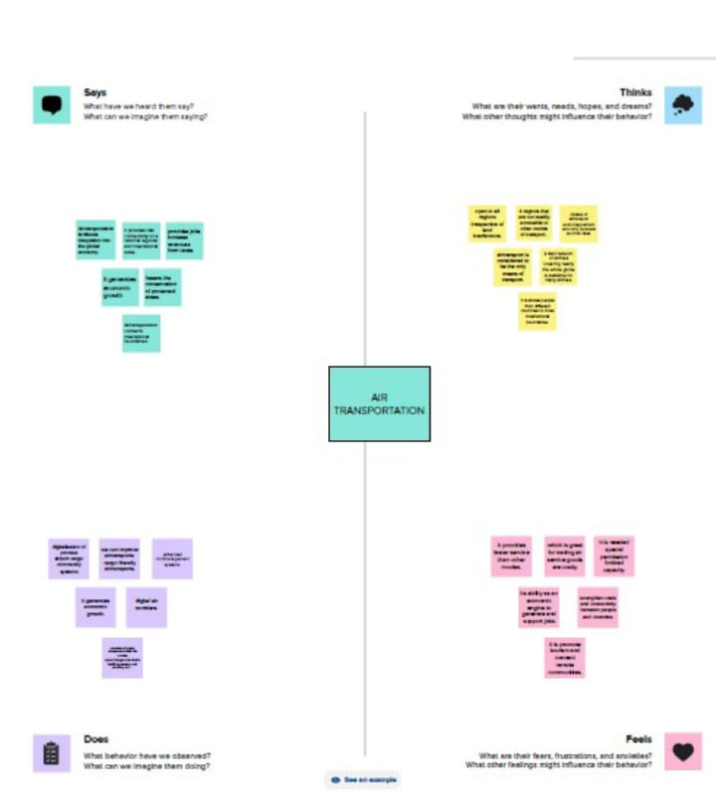

2.2 IDEATION AND BRAINSTORM MAP:

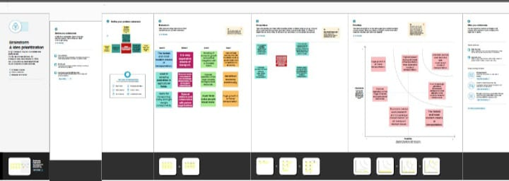3.RESULT:



4.ADVANTAGE AND DISADVANTAGE:

The cost is an indispensable process that provide numbers benefites.

The benifite of cost accounting come with a price.

5.APPLICATION:

This involves estimating all the expenses required to statrt and operate the business.

6.CONCLUSION:

In businessan estimate is acaluculated guess of what something will cost.